COSC 3380

Name: ______________ PS ID # ___

Project 1 ERD - WHAT:
(50 points)

Project 1 with Line Numbers
TEXTUAL ANALYSIS for
ERD Modeling

1. 15 points
2. 15 points
3. 5 points
4. 5 points
5. 10 points

PLEASE ENTER YOUR GRADE IN THIS BOX & ALSO on the CHECK SHEET:
1. (15 points)

# of Es: _

Table of Es:

E # | E Name
.
.
.

# of Attributes: _
Table of Attributes:

Attribute # | E# & Name | Attribute Name
.
.
.

2. (15 points)

# of Rs : _

Table of Rs

R # | R Name | Connecting Es# & Name & Cardinality
.
.
.

# of Descriptive Attributes: _
Table of Descriptive Attributes

Attribute # | R# & Name | Attribute Name
.
.
.
Total # of Attributes (Attributes + Descriptive Attributes): _

3. (5 points)

# of Vs: _

Table of Vs: V # V Name

V # | V Name
.
.
.

Table of Attributes:

V # | V Name | E# Attributes Input or Output
.
.
.

4. (5 points)

# of Ts: _

Table of Ts:

T # | T Name
.
.
.

Table of Attributes:

T # | T Name | E# Attributes Input or Output
.
.
.

1. (80 points)
TA and ERD

The DBMS allows users to share the data and query, access, and update the stored data. 3380 database provides evaluation, treatment, and rehabilitation of all types of acute and chronic injuries for both athletes and non-athletes. The highly skilled, certified therapists use their background of biomechanics, sport mechanics, and clinical experience to provide one-on-one comprehensive rehabilitation for all types of injuries. 3380 database stores information about their patients, therapists, therapies, and sessions.

Each patient’s name (last name, first name) and address (address, city, state, zip), as well as the balance due on their bill are stored in the 3380 database. Each patient is identified by a unique, four-digit patient number.

Therapy sessions identified by a unique number, the session date, and length of session are stored in the 3380 database.

Therapists are identified by a unique ID number that consists of 2 upper case letters followed by a three-digit number, name (last name, first name) and address (street, city, state, zip code)

Therapies are identified by a unique number which corresponds to the medical physical therapy code sent to insurance companies for reimbursement. Also a description and a billable unit of time, if any, are stored in the 3380 database. Time-based therapies are billed in groups of minutes. Service-based therapies are billed per service (no time is stored in the 3380 database).
The following reports are needed:
Schedule Report shows the session date and the last name and first name of the therapist sorted in chronological order last name, first name.
Patients Report shows the patient number, patient last and first name, session date and session number sorted in chronological order last name, first name.
Therapists Report shows the session date and therapist’s last name, first name, patient’s last and first name sorted in chronological order of the therapist’s last name, first name
The accounting department needs to know (the action of being informed) when a therapy code is updated in the Session table (the event). After creating a new table, CodeUpdates, write a trigger CodeUpdate that enters the date that the change was made, session number, patient number, the old therapy code and the new therapy code that was entered.
2. (20 points)
ERD Model:
(Please “Cut” and “Paste from the previous pages then rearrange to create the ERD Model, then delete everything with yellow background before submitting)
PLEASE DO NOT INCLUDE THESE PAGES AS YOUR DELIVERABLES! This is just for your use.

ERD LANGUAGE THAT MUST BE USED FOR TEXTUAL ANALYSIS!!!

Textual Analysis ERD Standard HIGHLIGHTS:
1. Es NEED LABELS beside NUMBERS. SINCE Es BECOME TABLES, an OPTION is to USE ALL UPPERCASE in LABELS. Labels should at least start with an Upper Case Letter.
TEMPLATE:
- Entity Set Template:
E1: Customer

You can copy and paste this E Template on the page where you want to use it!
EXAMPLE:
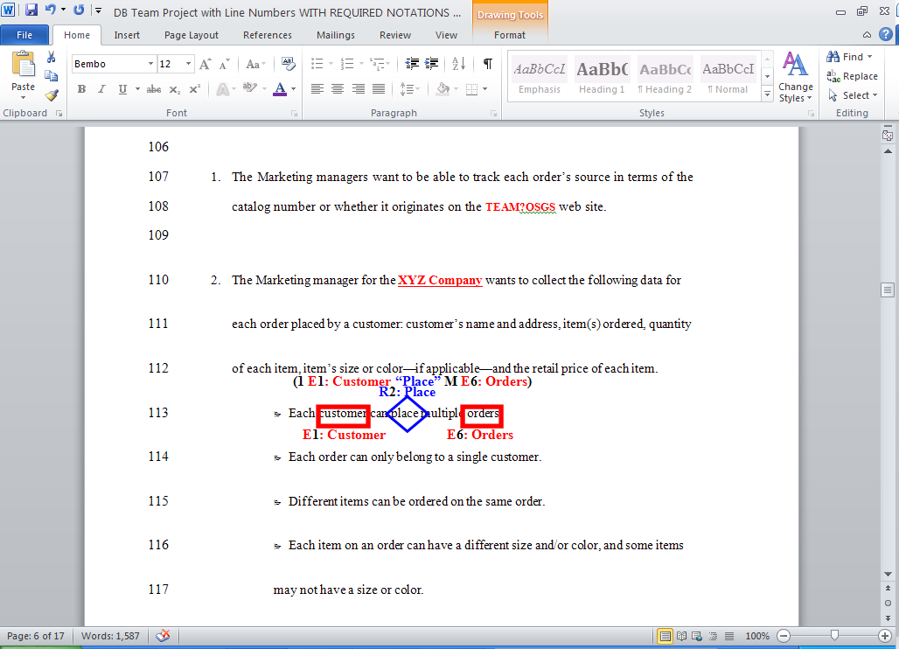

2. Rs NEED LABELS beside NUMBERS.
TEMPLATE:
- Relationship Set Template:
R2: Place
(1 E1: Customer “Place” M E6: Orders)

You can copy and paste this R Template on the page where you want to use it!

EXAMPLE:

3. As NEED LABELS beside NUMBERS and THEIR E#: LABEL or R#: LABEL.
TEMPLATE:
- Attribute Template:
E1: Customer – A1: C_ID

You can copy and paste this A Template on the page where you want to use it!

EXAMPLE:
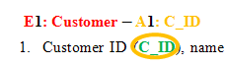

5. Es, Rs, and As are marked ONLY ONCE in the WHOLE TEXT!

- Trigger Template:
T1: ReOrder Item – Event: E4: Inventory - A3:INV_QOH on UPDATE
Condition: INV_QOH <= 3
Action: Email to E9:Employee – A5: Role = ‘WM’

You can copy and paste this T Template on the page where you want to use it!
- Views Template/Stored Procedure:
V1: View Items [Inventory Items REPORT] –

Inputs: 1. E2: Item – A1:ITEM_ID
Outputs: 1. E2: Item – A1:ITEM_DESC
2. E5: Category – A2:CAT_DESC
3. E2: Item – A2:ITEM_IMAGE

You can copy and paste this Template on the page where you want to use it!

